Assignment 3.1

* Checking the /user/acadgild/hadoop directory exists in the HDFS root directory.

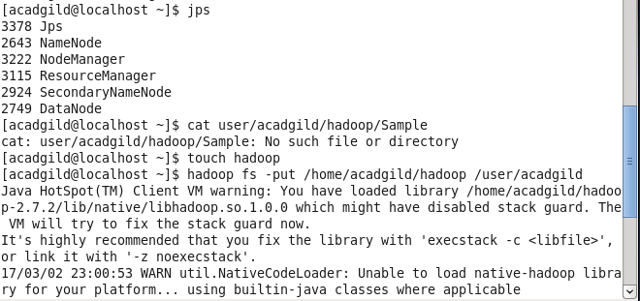

* The above screen shot shows that the directory is not exist. So that we create a file we use ‘touch’ command.
* Put the file into an HDFS use ‘put’ command.
* After executing the command we can check the file in the localhost:50070

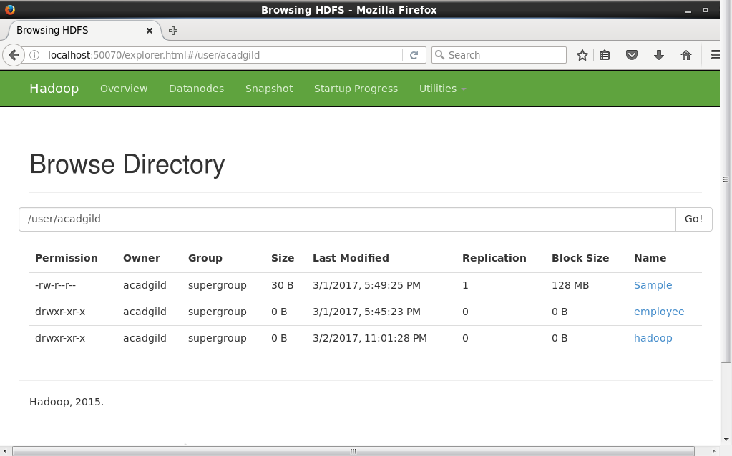

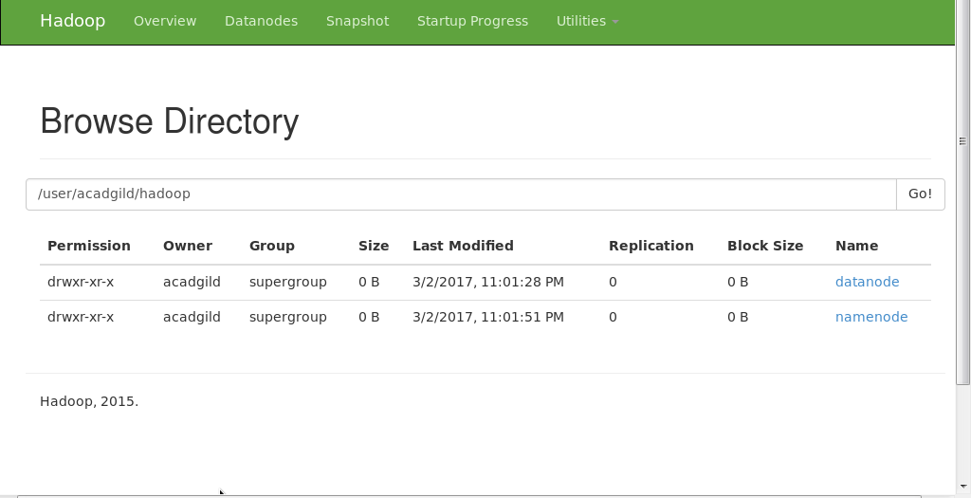

* The above screen shot shows that the hadoop folder present in the HDFS.
* We can check the availability from the terminal also.

